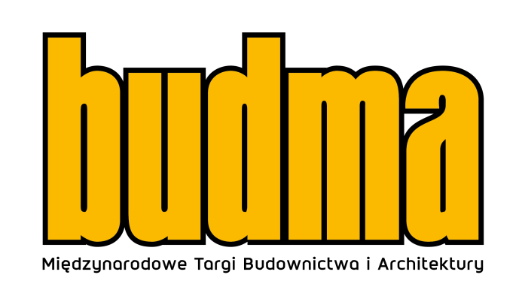
BUDMA 2023 - the only right direction
Are leaders in the construction and architecture sector ready to exploit the full potential of the changing dynamics of the industry and develop further to deliver benefits to their clients, the society and the environment more broadly? Answers to this and many other questions should be sought at the BUDMA fair - the event that brings people in business together.
The uncertainty in the construction sector resulting from the situation in Europe and the difficulty in predicting the future are currently very strong factors affecting the construction boom and investment opportunities. That is why it is worth coming to BUDMA 2023 to discuss solutions and prospects for the construction market in the coming years among industry professionals.
BUDMA - construction industry accelerator
Intensive preparations are under way for the BUDMA International Construction and Architecture Fair, to be held in Poznań on 31 January – 3 February 2023. During the upcoming edition, we can expect the presence of hundreds of manufacturers and distributors from all over the world who will show off their latest offer at the beginning of the year. This most important and eagerly awaited Polish event which integrates the international construction community, will be held under the motto: "KNOWLEDGE, RELATIONSHIPS, BUSINESS". It emphasises the great importance of the exchange of experience, the relevance of the topics discussed at the trade fair conferences, but also strongly emphasises the key importance of meetings, professional discussions and trust in business.
BUDMA is a prestigious space for the presentation of the latest proposals from manufacturers and distributors of the construction and architectural industry: windows, doors, gates, foundations, walls, ceilings, floors, roofs, steel and stone in construction, finishing materials, eco and energy-efficient construction, machines, tools, auxiliary equipment. The exhibition will be complemented by the WinDoor-tech Trade Fair of Machines and Components for Windows, Doors, Gates and Facades Production, which will include premiere demonstrations of technologically advanced solutions for the optimisation of production, announced by the slogan: "TOUCH THE TECHNOLOGY OF TOMORROW". This year, the flagship offer of the event shall also include a rich exhibition associated with the glass industry.
Build a global business
Personal meetings are irreplaceable in building business relations, therefore we are raising them to a new level at the upcoming BUDMA 2023. For the first time, an International Meeting Zone will be arranged - a special space for visitors from abroad, including a group of several hundred buyers participating in the Hosted Buyers programme, key guests from Poland or, last but not least, for the BUDMA and WinDoor-tech exhibitors themselves, where we will not only help them find potential business partners but also provide them with access to comprehensive and relevant knowledge on how to control their company development internationally. The value of these meetings will be the substance and assistance of advisors in the areas of: conducting international transactions, looking for new financing opportunities, security and transport and finally logistics itself in this new and changed supply chain reality. Networking will be assisted by a dedicated mobile application, suggesting possible contacts, creating a calendar of meetings and a map of meetings.
- The landscape of the construction industry is evolving rapidly, while production companies, contractors and participants throughout the supply chain need mentors like never before who can inspire and facilitate adaptation to the current market situation. The BUDMA fair is certainly an accelerator, supporting entrepreneurs in their business - it is a prestigious space for presenting the latest proposals of construction sector manufacturers and distributors as well as a venue for discussions among the architectural community, guaranteeing access to cutting-edge solutions, ensuring the building of long-term international business relations and networking,” says Marta Szydłowska, Director of the BUDMA International Construction and Architecture Fair.
The Hosted Buyers programme, which will once again be launched at the Budma 2023 International Construction and Architecture Fair, is also an opportunity to develop the company business in global markets. It provides unique opportunities to establish contacts with the best industry professionals, regardless of where they operate in the world. Its main objective is to develop the commercial dimension between Polish manufacturers and foreign contractors by arranging individual meetings between key foreign buyers and their selected exhibitors.
- Still in October, representatives of contractor companies and distribution networks from, among others, Greece, Georgia, Ireland, Lithuania, Luxembourg, Romania and Italy, confirmed their trade visits to BUDMA 2023. Practically every day we record enquiries from potential contractors from abroad, including both manufacturers and importers or distributors of construction materials. It can therefore be said that we are currently “opening” the list of countries represented at the Poznań construction industry fair,” reveals the director of BUDMA.
The power of meetings
The fair will be accompanied by respected events: Build4Future Construction Economic Forum, D&A Design and Architecture Forum as well as special zones: Professional Zone, Young Builder's Academy, Budma Design, Start-Up Arena, Eco-Trends Zone, Women in Construction Zone. The interesting programme of the fair, developed in direct cooperation with the most important trade associations and the media and often with the support of state institutions, attracts those market participants who want to know more to BUDMA.
A new attraction at this year's BUDMA will be the aforementioned Women in Construction Forum, during which female representatives of the sector will talk about their professional experience in the construction industry. The meeting will be divided into a lecture and workshop part, while its aim will be to strengthen the positive image, integrate and establish new business relations.
The Individual Investor Days also seem to be an interesting event which, during BUDMA, will enable those interested to seek inspiration, find out about the latest trends in construction and interior finishing, as well as access the latest technologies and finishing materials available on the market. The visitors will have at their disposal the construction and architectural advice zone, where they will be able to take advantage of consultations and support from interior designers and other industry specialists or learn about the latest Smart Home solutions and Eco-trends.
- As organisers, we are doing our best to ensure the high professional level of the event, to present a comprehensive offer for professionals from the construction and architecture sectors. We want to guarantee them space for fruitful business meetings, access to the latest technologies and the most up-to-date knowledge, emphasises the BUDMA fair director. - We are keen to ensure that every potential trade fair visitor perceives BUDMA as a space for talks with manufacturers, exchange of experience and updates on innovative solutions and products. - adds Marta Szydłowska.
Debates (about) the future
During the BUDMA 2023 International Construction and Architecture Fair, dozens of conferences and seminars will be held, among which the two-day Build4Future Construction Economic Forum and the 5th “D&A” Design and Architecture Forum deserve special attention. The programme of both events is based on a series of presentations and discussion panels, providing the basis for an open public debate on the upcoming prospects for the construction industry, the state of architecture in Poland and the direction in which it is or should be, heading. Each of the forums is attended by key representatives of the construction and architecture sectors - experts, practitioners and special guests who are unquestionable authorities in their fields, ensuring the highest level of substantive meetings.
Relevant events are also prepared for contractors and finishing companies – at this point, it is particularly worth emphasising the cooperation with the Polish Roofers Association, with which every year we organise interactive shows and championships, the Polish Floor Makers Association, whose members show off their extraordinary parquet-working skills, the Polish Windows and Doors Association promoting professional woodwork installation among fitters, or the Finishing Works Group, which organises an expert space for professionals. Many similar activities attracting and engaging fair visitors are also prepared by the exhibitors themselves.
- In the coming weeks we will start revealing more details about the events during BUDMA. You will be able to follow them on an ongoing basis on our website and in the social media, where we will also be presenting the registered exhibitors and the innovations they are preparing. - Director Szydłowska adds.

It is worth planning your participation today. You are cordially invited!
BUDMA: 31 January – 3 February 2023, Poznań International Fair.
https://www.budma.pl/pl/

