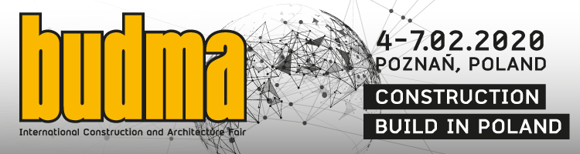

BUSINESS BEGINS AT BUDMA
BUDMA fair, the most popular and most important meeting of the construction industry in Poland and Central Europe, has been supporting the development of the sector for almost 30 years. Every year it serves as a presentation scene for Polish and foreign producers and distributors of materials, technologies and solutions for the construction industry. It is here that nearly 1,000 exhibitors from dozens of countries from around the world talk to their clients in a unique atmosphere, other than during everyday contacts and proudly presents options and unique solutions for up to 50,000 professionals who come to Poznan.
The beginning of the year is the perfect time for market premieres and implementation of new systems or solutions, which give impetus to adapt and dynamic development of the industry. Participation in the fair is an opportunity to meet in one place the most important producers (major brands, but also just entering the market). It is on BUDMA that the industry observes the latest trends and "touches" technological and product innovations. In Poznan, every year a discussion about the expectations of international groups of professionals takes place: producers and distributors of building materials, traders, architects, professionals and investors. Four days in Poznan is also a series of extremely interesting events, both substantive and interactive.
Next edition of the BUDMA fair, which will take place on 4-7 February 2020, promises to be impressive also in terms of quantity. The organizers emphasize that there are already more registered companies compared to the same period last year - five months before BUDMA over 75% of the exposition area is already reserved. Foreign suppliers, who are interested in launching new products on the Polish market in 2019, represented almost 40 countries. In the upcoming edition, this number may be even greater.
A lot about innovation, investing in new solutions, and creating innovative products will be presented in the Start-Up Zone also. Here, in turn, the "technologies of tomorrow” are presented, i.e. advanced solutions for construction and architecture, including those that are still waiting for investors and implementing in business.
The next BUDMA fair will be accompanied by the INTERMASZ construction machinery and equipment fair, the INFRATEC fair for technology and materials for infrastructure construction, and the fireplace industry fair KOMINKI.
BUDMA International Construction and Architecture Fair, 4-7 February 2020, Poznan.
www.budma.pl

