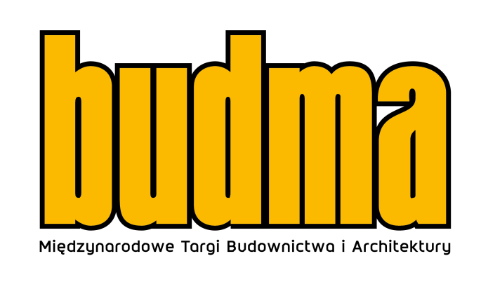

Knowledge, relationships, business - BUDMA 2023 is coming
Intensive preparations are under way for the BUDMA International Construction and Architecture Fair to be held in Poznań on 31 January – 3 February 2023. During the upcoming edition, we can expect the presence of hundreds of manufacturers and distributors from all over the world, who will show off their latest offer at the beginning of the year. This most important and eagerly awaited Polish event, which integrates the international construction community, will be held under the motto: "KNOWLEDGE, RELATIONSHIPS, BUSINESS". It emphasises the great importance of the exchange of experience, the relevance of the topics discussed at the trade fair conferences, but also strongly emphasises the key importance of meetings, professional discussions and trust in business.
BUDMA is a prestigious space for the presentation of the latest proposals from manufacturers and distributors of the construction and architectural industry: windows, doors, gates, foundations, walls, ceilings, floors, roofs, steel and stone in construction, finishing materials, eco and energy-efficient construction, machines, tools, auxiliary equipment. Machines, tools and components for the production of windows, gates and facades complement the exhibition.
The fair will be accompanied by respected events: Build4Future Construction Economic Forum, D&A Design and Architecture Forum as well as special zones: Professional Zone, Young Builder's Academy, Budma Design, Start-Up Arena, Eco-Trends Zone, Women in Construction Zone.

BUDMA trade fair, 31 January – 3 February 2023, Poznań.
https://www.budma.pl/pl/

