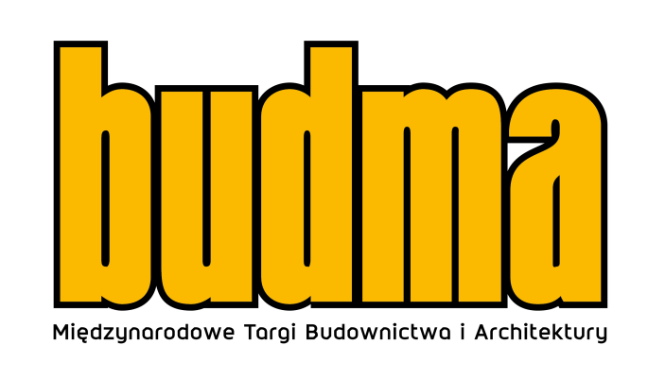

Direction - the world! BUDMA 2023 fair
BUDMA is one of the leading industry events on the international stage and attracts businesses from all over the world. The Hosted Buyers Programme and the International Meeting Zone play a key role in winning customers. They will provide participants with the opportunity to find potential business partners from abroad and access to comprehensive knowledge on how to globally manage the growth of a company will make it easier to achieve this goal.
The current condition of the economy requires representatives of the construction industry to be well prepared and adapt quickly to the emerging challenges. The industry landscape is evolving rapidly, and manufacturing companies, contractors and participants throughout the supply chain need mentors like never before who can inspire and facilitate adaptation to the current market situation. The BUDMA fair is certainly an accelerator, supporting entrepreneurs in doing business, providing guaranteed access to cutting-edge solutions, facilitating the building of long-term international business relationships and networking. At present, entrepreneurs are intensively searching for solutions that will help them to go through the crisis more smoothly. An excellent opportunity to establish new global contacts is the BUDMA fair, while conferences and industry debates provide an opportunity to talk about optimisation, as well as to offer machines, tools and components for the production of joinery and facades, as part of the WinDoor-tech trade fair taking place on the same date.
- As trade fair organisers, we initiate meetings and the exchange of experience, support communication and constantly seek global solutions that further drive business development. For the first time at BUDMA 2023, the International Meeting Zone will be organised - a special space for foreign visitors, including a group of several hundred buyers participating in the Hosted Buyers programme, key guests from Poland or, last but not least, for BUDMA and WinDoor-tech exhibitors themselves, where we will not only help them find potential business partners, but also provide them with access to comprehensive and relevant knowledge on how to control their company development internationally,” emphasises Marta Szydłowska, Director of BUDMA International Construction and Architecture Fair.
The value of these meetings will be the substance and assistance of advisors in the following areas: conducting international transactions, looking for new funding opportunities, security and transport and finally logistics itself in this new, changed supply chain reality. A dedicated mobile application suggesting possible contacts, creating a calendar and a map of meetings, will help to build a network of relationships.
Build a global business
For the seventh year in a row, the Hosted Buyers programme, which has been very well received by exhibitors and which brings representatives of foreign retail chains, purchasing groups, wholesalers or building material distributors from the most promising export markets to Poznań, is continued. So far, more than 3000 foreign buyers have visited BUDMA as part of this programme!
- Still in October, representatives of construction contractors and distribution networks from, among others, the Czech Republic, Greece, Georgia, Spain, Ireland, Lithuania, Luxembourg, Mongolia, Norway, Romania, Sweden, Turkey, Uzbekistan and Italy confirmed their trade visits to BUDMA 2023. Practically every day we receive enquiries from potential foreign contractors and these include both manufacturers and importers or distributors of building materials. It can therefore be said that we are currently “opening” the list of countries represented at Poznań construction fair,” reveals the BUDMA director.
It is said that the fair is a mirror in which the condition of the economy is reflected. At present, the fair mirror shows anxiety about the future. The contacts developed at the BUDMA International Construction and Architecture Fair provide opportunities for international business development, while the topics discussed at the events support the industry. The knowledge gained at BUDMA makes it easier to respond to changes, while the mechanisms introduced to the participants allow the Polish representatives of the construction sector not only to survive uncertain times, but even to emerge from them successfully.
It is worth planning your participation today. You are cordially invited!
BUDMA fair: 31 January – 3 Fabruary 2023, Poznań International Fair grounds.
https://www.budma.pl/pl/
The WinDoor-tech Trade Fair of Machines and Components for Windows, Doors, Gates and Facades Production will be held at the same time.

